

Republic of the Philippines
Department of Education
National Capital Region
DIVISION OF QUEZON CITY SCHOOLS
Quezon City, Metro Manila

FIRST PERIODICAL TEST
MATHEMATICS IV
SY 2014 - 2015
DIRECTIONS: Choose the correct answer. All answers must be simplified with the correct
unit. Calculator is NOT allowed.

- Which of the sets of ordered pairs defines a function?
A){(-3 , 2), (-2, 3), (-1, 4), (-2, 5) } C) {(1 , 3), (2, 4), (3, 5), (4, 6)}
B) {(-1 , 2), ( 0, 3), ( 0 , 4), (1, 5) } D) {(0, 1), (1, 2), (2, 3), (1, 4)}
- What are the coordinates of a point three units below the x-axis and two units to the right of the y-axis?
- (-3,2) B) ( 3, -2) C) (-2,3) D) (2,-3)

3. Which of the following rules best describes the set of ordered pairs 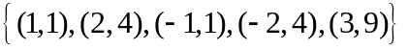?
A) y is the square of x. C) y is twice x.
B) y is the square root of x. D) y is the absolute value of x.

- Given the relation R= {(3,5), (7,9), ( x – 3, 13), (15,17)}, where y = x + 2, what is the value of x?
- 6 B) 10 C) 14 D) 18

- Given: f(x) = 5 – 2x, evaluate f ( x + 1)
- 7 – 2x B) 3 + 2x C) ‒2x + 3 D) 2x ‒ 7

- What is f(-1) if f(x) = ‒2x² ‒ 5 ?
- -10 B) -7 C) -3 D) 2

- What is the x-intercept of f(x) = 1/3 x – 5?
- -15 B) -5 C) 0 D) 15
- Which of the graphs does NOT define a function?
A) C)

B) D)

- If f(x) = 5x − 3 and g(x) = x² + 3x − 1, then what is f(x) subtracted from g(x) ?
A) 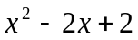 C) 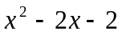
B) 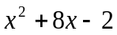 D) 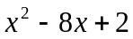
10. Given f(x) = 3x + 5 and g(x) = x³ + 2, what is the value of f [ g(2) ] ?
A) 29 B) 35 C) 41 D) 53

11. Which of the following is NOT a function?
A) 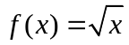 B) 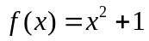 C)  D) 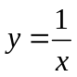

12. Rey can encode 40 words per minute. How many words can he encode in 1 ½ hrs?
A) 3600 C) 2400
B) 360 D) 4800

13. If f(x) = 4x – 3, which of the following statements is/are TRUE?
I. f(1) > f(-1) II. f(0) < f (1) III. f (-1) > f (0)

- I only B) II only C) I and II only D) II and III only
14. What is the domain of the function y = ?
- { x l x 4 } C) { x l – 4 x 4 }
- { x l x - 4 or x ≥ 4 } D) { x l x 3 }
15. Which correspondence/s defines a function?
- One-to-one ii. One-to-many iii. Many-to-one
- i only B) ii only C) ii and iii D) i and ii
- A line passes through the point P ( 3 , – 4). If its slope is – 7 , what is its equation ?
A) y = 7x + 17 B) y = ─ 7x + 17 C) y = ─ 7x + 25 D) y = 7x – 25

17. Which of the following defines a linear function?
A) 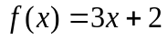 C) g(x)= ( x – 4 )( x – 4)
B) 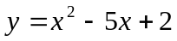 D) 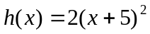
18. What is the slope of a line parallel to the line whose equation is 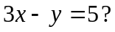
A) 3 B) −3 C) D)
- What is the equation of the line described in # 13 if it passes through the point ( 2, − 3 ) ?
A) 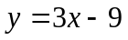 B) 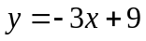 C) 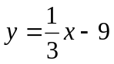 D) 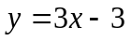
- Find two consecutive positive even integers whose sum is 38.
A) 12 and 26 B) 18 and 20 C) 14 and 24 D) 16 and 22
- Given the linear function 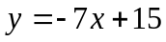, what does the constant 15 stand for?
A) slope B) x-intercept C) y-intercept D) root
- Express 4x – y – 5 = 0 in the form y = mx + b.
A) y = − 4x + 5 B) y = 4x + 5 C) y = − 4x – 5 D) y = 4x – 5
- One of the following describes the graph of a constant function. Which one is it?
A) The line is horizontal. C) The line rises to the left.
B) The line rises to the right. D) The line is vertical.

24. What is the slope of a line whose equation is y = - 3x + 2?
A) -3 B) -1 C) 3 D) 6
- A line passes through the origin. If its slope is – 4 , what is its equation ?
A) y = 4x B) y = ─ 4x C) y = x + 4 D) y = x ─ 4
26. The sum of the squares of two consecutive numbers is 265. Find the numbers.
- 14 and 16 B) 13 and 15 C) 12 and 11 D) 11 and 13
- Write the equation 3x − y = 5 in slope-intercept form.
A. y = 3x – 5 B. y = 3x + 5 C. y = −3x – 5 D. y = −3x + 5
28. What is the slope of the line passing through the points (1, -2) and (2,4) ?
A) 2 B) 6 C) -2 D) -6

- When equated to zero, the linear equation 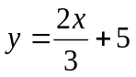 is equivalent to
A) 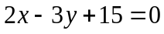 B) 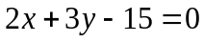 C) 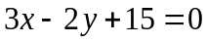 D) 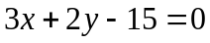
30. What is the slope of a line perpendicular to the line whose equation is 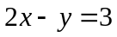?
A) 2 B) ½ C) -2 D) – 1/2

- Which of the following is NOT a graph of a linear function?
- Horizontal line B) Diagonal line C) Vertical line D) none of these

- Gasoline costs Php 49.10 per liter. Which equation represents the cost y of x liters of gasoline bought?
A) y = 49.10 + x B) 49.10 (x) C) y = 49.10-x D) y = 49.10 / x

- At what point does the graph of y = 3x – 6 intersects the x – axis?
A) (2,0) B) (0,2) C) ( -6,0) D) (0, -6)

- The ordinate and abscissa of a point are -3 and 4, respectively. In which quadrant is it located?
A) Q I B) Q II C) Q III D Q IV

- If the product of the slopes of two distinct lines is equal to -1, then what can you say about the lines?
A) parallel B) perpendicular C) coinciding D) intersecting

36. Which of the following is NOT a quadratic function?
A) B) g(x)= ( x – 4 )² C) D)
37. A certain plant is now 10 cm tall. It is growing steadily at the rate of 3 cm every week. How
high will the plant be after 5 weeks?
A) 18 cm B) 23 cm C) 25 cm D) 30 cm

38.Using the same conditions stated in # 37, how high in cm will the plant be after w weeks?
A) 3w B) w + 10 C) 3w + 10 D) 3w – 10

39. What represents the graph of any quadratic function?
A) point B) line C) parabola D) circle

40. The graph of a quadratic function may intersect the e-axis at how many points?
A) 0 B) 1 C) 2 D) all of these

41. What are the roots of the quadratic equation equivalent to (2x-1) (x + 7) = 0
- 1 and 7 B) ½ and -7 C) – ½ and 7 D) – 1 and 7

42. What is the nature of the roots of x² + 4x+7 = 0
A) imaginary B) real and equal C) irrational D) rational and unequal

43. Find the length of the side of the square whose perimeter is numerically equal to its area.
A) 0 B) 4 C) 8 D) 16

44. Change f(x) = 2x² + 8x+5 into the form f(x) = a ( x – h)² + K
A) f(x) = 2 ( x +2)² – 3 C) f(x) = - 2 ( x +2)² – 3
B) f(x) = 2 ( x - 2)² – 3 D) f(x) = - 2 ( x +2)² + 3

45. . The vertex form of 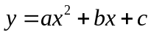:
A) 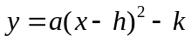 C) 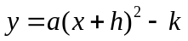
B) 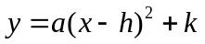 D) 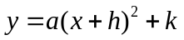

46. What are the coordinates of the vertex of the quadratic function y = 3x² + 4x+1?
A) ( 2/3, 1/3) B) ( - 2/3, - 1/3) C) ( 4/3, 1/3) D) ( - 2/3, 1/3)

47. Change f(x) = - 2 ( x + 6 )² – 3 into the form f(x) = ax² + bx+c
A) f(x) = - 2x² - 24x – 75 C) f(x) = - 2x² + 24x – 75
B) f(x) = 2x² - 24x – 75 D) f(x) = - 2x² - 24x + 75

48. Marie has a rectangular garden with a perimeter of 72m and an area of 308 sq.m. What is the length and
width of the garden?
- L= 77m & W = 4 m C) L = 20 m & 16 m
- L = 22 m & W = 14 m D) L = 32 m & 10 m

49. Find two numbers whose sum is 12 and whose difference between their squares is 48.
A) 5 and 7 C) 3 and 9
B) 4 and 8 D) 2 and 10

50. A square garden has a side of ( 4x - 1) meters. What is the area of the garden?
A) (4x² + 8x – 1) sq.m. C) (16x² - 8x +1) sq.m.
B) ( 16x – 4) sq. m. D) (16x² + 1) sq.m.

‒ END –

